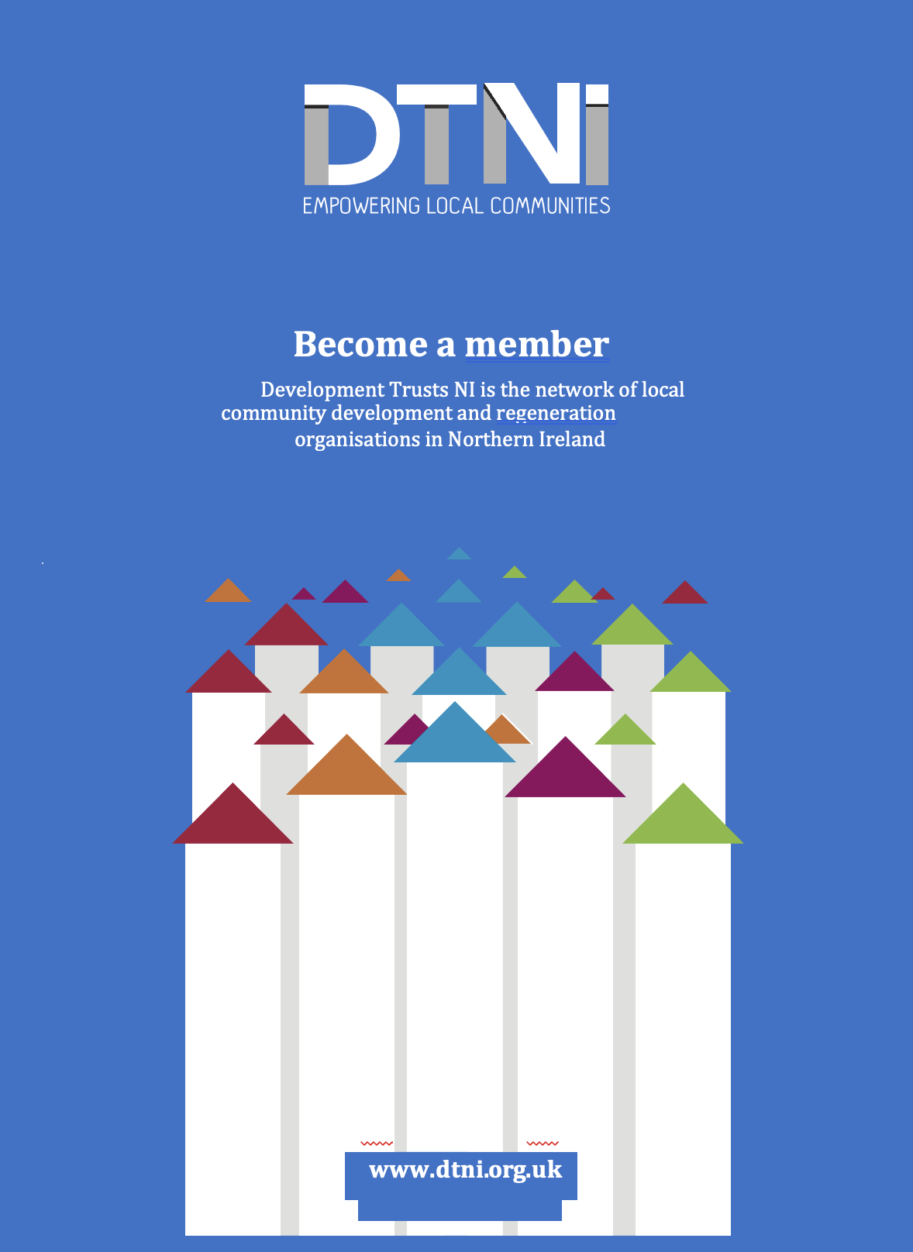
Membership Application

DTNI represents its members by providing development support for community ownership of public assets. We advocate for community rights and the role of communities in the local economy.

We are dedicated to the development needs of our members and to the following principles:

- Shared Learning: we believe that society, communities, and the DTNI network are stronger when we share knowledge and skills and work together in solidarity with each other.
- Accountability: we believe that DTNI should be fully accountable to its members and funders for what it does. In turn, we also believe that policy and decision makers should be accountable to the people.
- Participative democracy: we believe that democracy is stronger where ordinary people come together in community-based organisations, build their assets and resources, and actively and regularly contribute to decisions that affect their lives.
- Social and economic justice: we believe that a fair and equitable society is a healthier and happier one.
- Integrity: we believe that it is important to build trust between people by acting to the highest standards of professionalism and integrity.
- Independence: we believe it is important that DTNI acts as an independent voice in promoting its mission and values.

Development Trusts are locally based, not-for-profit organisations that provide services in the community and seek to both enhance the local economy and contribute towards the regeneration of their area. Development Trusts can have many legal forms, all of which support community benefit and aim to protect the common good.

Our role

DTNI’s agenda on behalf of its membership includes:
- A core focus is on ownership of assets and community enterprise as a means of creating sustainable approaches to local regeneration.
- Promoting independence by supporting communities to explore community enterprise approaches so that they can earn income to be used for community benefit.
- Advocating for more local commissioning from public bodies that supports third sector organisations to provide services to meet the needs of both communities of place and communities of interest.
- Promoting peer exchange, learning, and collaborative partnership working amongst both third sector and other sectoral organisations.
- A policy and advocacy role which enables key local regeneration organisations to contribute to the delivery of a joined-up approach to regeneration and to growing their local economy.
- Advocating for a social justice-based approach designed to bring about positive social economic and environmental change to make our communities fairer and more inclusive. This includes supporting local economic initiatives.
- Encouraging good relations to support and strengthen reconciliation and to promote transformation within communities, recognising the unique role that each sector plays in long-term sustainable and cohesive social and economic regeneration.

Membership Application

Membership
Our network of development trusts in NI forms part of the wider development trust movement across Britain.

We welcome applications from:
- individuals
- tenant associations
- community development organisation
- community social enterprises
- organisations representing a particular geographic area (communities of place)
- organisations representing a particular interest group (communities of interest)
- voluntary sector
- public sector
- faith-based organisations

Assets and Community Asset Transfer

DTNI staff can assist and advise you in support of your bid for a public sector asset through the Community Asset Transfer policy framework. We have developed a number of resources designed to support members to both assess capacity and to build organisational capability around the following areas:
- Investment readiness (IREAD tool www.iread.org.uk).
- Training on asset acquisition, development, and management, including community asset transfer.
- Facilities management training.
- Developing an enterprise focus - training modules and mentoring on community asset transfer, feasibility screening, business planning, financial planning, governance, and people and assets.
- Learning exchange, study visits, and networking within Northern Ireland and across Britain and Ireland.
- Advocacy and information provision (bi-monthly e-bulletin, conferences, and policy seminars).

Membership Application

FULL MEMBERSHIP

Aimed at community and voluntary sector organisations that meet assessment value criteria and development trust approach. (Please see our value statement on last page)

Benefits include:

- Access to development support and expert help from DTNI staff in areas such as
Governance​
Organisational development​
Financial planning and reporting​
Funding​
Asset transfer and community ownership
- Access to resources
- Shared learning site visits, involvement in peer-to-peer groups
- Access to webinars and events
- Discounted rates for training, conferences and summits.
- We support and promote members interests and activities through our ebulletin & social media. ​

SUPPORTER MEMBERSHIP

Open to any individual or unincorporated group

- Receive regular information and updates from DTNI.
- We will support and promote your activities through our ebulletin & social media.

ASPIRING MBERSHIP

Open to early-stage groups that are aspiring to set up a development trust.

- Your organization is represented in the DTNI members directory.

MEMBERSHIP +

For all organisations interested in the work of DTNI looking to make meaningful and mutually beneficial connections with community organisation’s (Voluntary, Community & Social Enterprise organisation’s, public sector/local authority/private sector)

- Full member benefits which include 1-day bespoke consultancy support from senior staff providing strategic advocacy support and policy planning.

Membership Application

Correspondence
Organisation Name:
Main Contact: | Job Title:
Address:

Post Code:
Telephone: | Mobile:
Email: | Web:
Facebook:  LinkedIn | Twitter:

Membership Category

Please indicate membership category you are requesting.
You will be invoiced in due course for the member category of your choice.

Membership Fee

You will be invoiced in due course for the member category of your choice.

Full membership £75

Supporter membership £25

Aspiring membership Free

Membership + £500

Membership Application

About Your Organisation

Tell us briefly about your organization: provide us with some key facts such as the year established, the facilities and services you manage, the projects and activities you deliver etc. These details will be made available in our member directory on the DTNI website (you will be provided with options to edit and update your organisation’s membership).

Max 250 words

Legal Form

What is the legal Structure of your organization (tick all that apply) |  | Company number/Charity number
Charity

Community Interest Company (CIC)

Company Limited by Guarantee

Industrial and Provident Society

Company Limited by Share Capital

Unincorporated Association

Other – Please specify.

Geography & Interest
Please indicate whether your organisation works in and or on behalf of:

An urban area.

A rural area

Mixed- urban/rural

A community of interest
(i.e., on behalf of a specific group)

Electoral Wards
Please list the main electoral wards that your organisation works in
1.

2.

3.

Annual Turnover
Please tell us your current annual turnover
£

Areas of Work (Please tick all relevant)

Housing

Rural development

Renewable energy

Retail & hospitality

Sports/leisure/recreation/tourism

Training/employment

Transport

Youth services

Urban development

Arts and culture

Disability services

Childcare services

Community development

Community gardens

Community hubs

Development support

Environment

Heritage & Buildings

Any Other Information
Let us know of anything you feel is of relevance to your application not already requested above (Max 250 words)

Membership Application

Declaration of Support

We wish to become a member of DTNI as per the member category ticked above.
We agree to pay the annual membership fees as requested.
We agree to the Development Trusts value statement – see next page.
We understand that DTNI will use the contact details provided on this form to send information to us relating to DTNI membership and other services.
We are happy for DTNI to share information about our organisation with other members and related agencies, and to allow these details to be made available via the DTNI website.
I understand that membership to DTNI is subject to review.

Signed

Date

Please return this membership application to DTNI by email or post to:

admin@dtni.org.uk

DTNI, 3rd Floor,
Cathedral Quarter Managed Workspace
109 – 113 Royal Avenue, Belfast,
BT1 1FF

Development Trusts NI Value Statement

Community Development Trusts (CDTs) are locally based, not-for-profit organisations that provide services in the community and seek to both enhance the local economy and contribute towards the regeneration of their area.

We know that strong and successful community-based organisations run by and for local people are essential in tackling many of the social, environmental, and economic challenges we face.

DTNI support local community organisations who operate under these principles to enable them to unlock their power. We envision a future where community assets are owned by and provide benefit to the community, eventually reducing demands on the public purse and developing a real and sustainable partnership with a range of service providers.

Community Development Trusts manage and maintain assets for the purpose of meeting local need. We advise our members to consider how their assets will be managed in the future to remain in local use.

This document draws our membership network together by stating our commitment to a shared vision of a fair society where every community thrives.

As a network we promote shared learning: Your commitment to the network involves sharing your experience and expertise with other members.

All member organisations, groups and individuals will strive to adopt behaviours that reflect these values.

Additionally, we encourage all organisations who join to:

- Develop a sustainable business model.
- Offer a range of different services depending on what their community needs.
- Create and distribute wealth, providing opportunities by employing local people, using local supply chains and investing surplus in services.
- Bring people together and collaborate with other local groups and organisations.

To get the most out of the DTNI membership network members agree that everyone benefits when:
- Members actively participate and positively contribute to the network.
- Our membership is diverse, and our network is inclusive.
- We connect, share and learn from each other.
- We treat each other with respect.
- We involve local people in the decisions that affect them.

Signed:

Name:

Organisation:

